
Holy Cross College

Semester 2 Examination 2012

Question/Answer Booklet

Year 10 Science
Please place your student identification label in this box
(Modified)

Student Name
Student’s Teacher

Time allowed for this paper

Reading time before commencing work: 10 minutes
Working time for paper: 100 minutes

Materials required/recommended for this paper

To be provided by the supervisor

This Question/Answer Booklet
Data Sheet

To be provided by the candidate

Standard items: pens, pencils, eraser, correction fluid, ruler, highlighters.
Special items: non-programmable calculators satisfying the conditions set by the School Curriculum and Standards Authority for this course.

Important note to candidates

No other items may be taken into the examination room. It is your responsibility to ensure that you do not have any unauthorised notes or other items of a non-personal nature in the examination room. If you have any unauthorised material with you, hand it to the supervisor before reading any further.

Structure of this paper

Section | Number of questions available | Number of questions to be answered | Suggested working time  (minutes) | Marks available | Percentage of exam
Section One:  Multiple Choice | 55 | 55 | 40 | 55 | 38
Section Two:  Short Answer | 16 | 16 | 45 | 75 | 51
Section Three:  Comprehension | 9 | 9 | 15 | 17 | 11
 |  |  |  | 147 | 100

Instructions to candidates

1. The rules for the conduct of examinations at Holy Cross College are detailed in the College
Examination Policy. Sitting this examination implies that you agree to abide by these rules.

2. Write your answers in this Question/Answer Booklet.

3. Working or reasoning should be clearly shown when calculating or estimating answers.

4. You must be careful to confine your responses to the specific questions asked and to follow
any instructions that are specific to a particular question.

5. Spare pages are included at the end of this booklet. They can be used for planning your
responses and/or as additional space if required to continue an answer.

• Planning: If you use the spare pages for planning, indicate this clearly at the top of the
page.
• Continuing an answer: If you need to use the space to continue an answer, indicate in
the original answer space where the answer is continued, i.e. give the page number.
Fill in the number of the question(s) that you are continuing to answer at the top of the
page.

Achievement Standards

The atomic structure and properties of elements are used to organise them in the Periodic Table.

Different types of chemical reactions are used to produce a range of products and can occur at different rates.

The motion of objects can be described and predicted using the laws of physics.
SECTION 1 MULTIPLE CHOICE (55 marks)

Choose the best answer for each question in the Multiple Choice Question booklet.

Mark your selection with a cross.

1 | (a) | (b) | (c) | (d) |  | 31 | (a) | (b) | (c) | (d)
2 | (a) | (b) | (c) | (d) |  | 32 | (a) | (b) | (c) | (d)
3 | (a) | (b) | (c) | (d) |  | 33 | (a) | (b) | (c) | (d)
4 | (a) | (b) | (c) | (d) |  | 34 | (a) | (b) | (c) | (d)
5 | (a) | (b) | (c) | (d) |  | 35 | (a) | (b) | (c) | (d)
6 | (a) | (b) | (c) | (d) |  | 36 | (a) | (b) | (c) | (d)
7 | (a) | (b) | (c) | (d) |  | 37 | (a) | (b) | (c) | (d)
8 | (a) | (b) | (c) | (d) |  | 38 | (a) | (b) | (c) | (d)
9 | (a) | (b) | (c) | (d) |  | 39 | (a) | (b) | (c) | (d)
10 | (a) | (b) | (c) | (d) |  | 40 | (a) | (b) | (c) | (d)
11 | (a) | (b) | (c) | (d) |  | 41 | (a) | (b) | (c) | (d)
12 | (a) | (b) | (c) | (d) |  | 42 | (a) | (b) | (c) | (d)
13 | (a) | (b) | (c) | (d) |  | 43 | (a) | (b) | (c) | (d)
14 | (a) | (b) | (c) | (d) |  | 44 | (a) | (b) | (c) | (d)
15 | (a) | (b) | (c) | (d) |  | 45 | (a) | (b) | (c) | (d)
16 | (a) | (b) | (c) | (d) |  | 46 | (a) | (b) | (c) | (d)
17 | (a) | (b) | (c) | (d) |  | 47 | (a) | (b) | (c) | (d)
18 | (a) | (b) | (c) | (d) |  | 48 | (a) | (b) | (c) | (d)
19 | (a) | (b) | (c) | (d) |  | 49 | (a) | (b) | (c) | (d)
20 | (a) | (b) | (c) | (d) |  | 50 | (a) | (b) | (c) | (d)
21 | (a) | (b) | (c) | (d) |  | 51 | (a) | (b) | (c) | (d)
22 | (a) | (b) | (c) | (d) |  | 52 | (a) | (b) | (c) | (d)
23 | (a) | (b) | (c) | (d) |  | 53 | (a) | (b) | (c) | (d)
24 | (a) | (b) | (c) | (d) |  | 54 | (a) | (b) | (c) | (d)
25 | (a) | (b) | (c) | (d) |  | 55 | (a) | (b) | (c) | (d)
26 | (a) | (b) | (c) | (d)
27 | (a) | (b) | (c) | (d)
28 | (a) | (b) | (c) | (d)
29 | (a) | (b) | (c) | (d)
30 | (a) | (b) | (c) | (d)
SECTION 2 SHORT ANSWER (75 marks)

Attempt all questions. Write your answers in the spaces provided.

1. Classify the following elements as alkali metals, transition metals, metalloid (semi-metals),
halogens or noble (inert) gases. Use the periodic table on the data sheet provided.

K Ge He Cu Fr Cl Ag Ar

Alkali Metal | Transition Metal | Metalloid  (Semi-Metal) | Halogen | Noble (Inert) Gas

(4 marks)

2. Complete the following table showing the constituent particles of each element.

ELEMENT | PROTONS | NEUTRONS | ELECTRONS
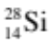
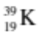
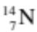

(4 marks)

3. Draw clear diagrams to show the electron configurations of the following elements.
Remember to include the number of particles in the nucleus.

(a) 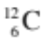 (b) 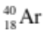

(c) 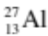

(6 marks)
4. Write the name for each of the following compounds.
(Note Some of them are ionic and you need your list of ions.)

FORMULA | NAME
KNO₃
Mg₃(PO₄)₂
Al₂(SO₄)₃
PBr₃
FeI₃
Ba(CH₃COO)₂
S₂I₄

(7 marks)

5. Balance the following equations.

(a) Al + HCl  AlCl₃ + H₂

(b) C₃H₈ + O₂  CO₂ + H₂O

(c) NaOH + Fe(NO₃)₂  Fe(OH)₂ + NaNO₃

(6 marks)

6. In the table below, choose the correct meaning for each word given. Write the letter of the
correct meaning next to the word.

WORD | CORRECT  LETTER | MEANINGS
neutron |  | A - a row of the periodic table.
period |  | B - building block of matter.
molecule |  | C - two or more elements chemically combined.
compound |  | D - two or more atoms chemically combined.
group |  | E - column of the periodic table.
atom |  | F - particle with no charge.
(3 marks)

7. Write complete word equations for the following acid reactions.

(a) zinc carbonate + nitric acid 

(b) potassium hydroxide + sulphuric acid 

(c) calcium carbonate + hydrochloric acid 

(6 marks)

8. Some students investigated the movement of a dynamics trolley across a bench using a ticker
timer to record the motion. The timer puts 50 dots per second (1 dot-spacing = 0.02 sec) onto
the tape, and the tape is shown below.

. . . . . . . . . . . . . . . . . . . .

(a) Using any 6 dots of your choosing, perform a calculation of the average speed. Show
all of your working below.

d = cm = m (Remember to convert.) (1 mark)

t = s (1 mark)

(Calculation: use speed, d, t.)

(2 marks)

(b) What is the difference between a ticker tape for constant velocity and acceleration?
Draw a representation of each tape below.

(i) Constant Velocity

(ii) Acceleration

(2 marks)

9. Vincent dropped a stone down a well and saw it hit the bottom 3.5 s later. Calculate the
velocity of the stone at impact, given the acceleration due to gravity is 9.80 ms⁻² and the
stone starts from rest when it is dropped.
(Hint: Use v, u, a, t.)

(3 marks)

10. Sean steps on the brake pedal of his car and applies a regarding force of 2100 N to
slow his 750 kg car. Calculate his car's deceleration.
(Hint: Use F, m, a.)

(3 marks)
11. Max has a mass of 57 kg on Earth. He is lucky enough to be selected for a junior astronaut
programme and journeys to the International Space Station (ISS) for a 3-month stay.

(a) Calculate Max's weight on Earth.
(Hint: Use F_{w}, m, g.)

(3 marks)

(b) Max "floats” in space within the ISS. Is he weightless? Explain your answer.

(2 marks)

(c) What is Max's mass in the space station?

(1 mark)

12. A plane takes off from a country airstrip and flies 250 km West, then 500 km South. It lands
on a farm owned by the pilot. The total time of flight is 1.5 hours.

(a) Draw a vector diagram to show the addition of the vectors and the
resultant vector. (Use a scale of 1.0 cm = 100 km.)

N
W
E
S

(3 marks)

(b) Calculate the displacement of the plane from its starting point by measuring the length
of the resultant vector. Use a protractor to find the direction of the resultant.

(3 marks)

(c) Calculate the distance travelled by the plane for the journey. Give your answer in km.

(2 marks)

13. A force of 36 N acts on a mass of 24 kg. What is the acceleration of the mass?
(Hint: Use F, m, a.)

(3 marks)

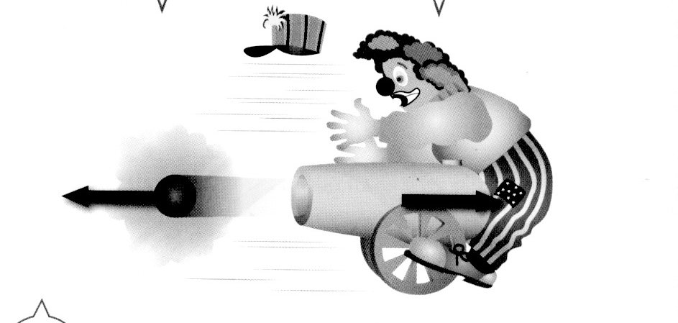
14. Look at the diagram showing a clown and a cannon at
a circus. Analyse it and explain why the cannon hits
the clown, using Newton's Laws in your explanation.

(2 marks)
15. What is the resultant force acting on the parachutist?
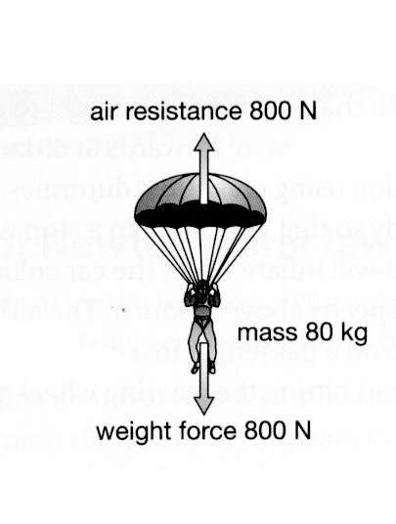

(2 marks)
16. The graph below shows the motion of a bicycle over a 20.0 s period.
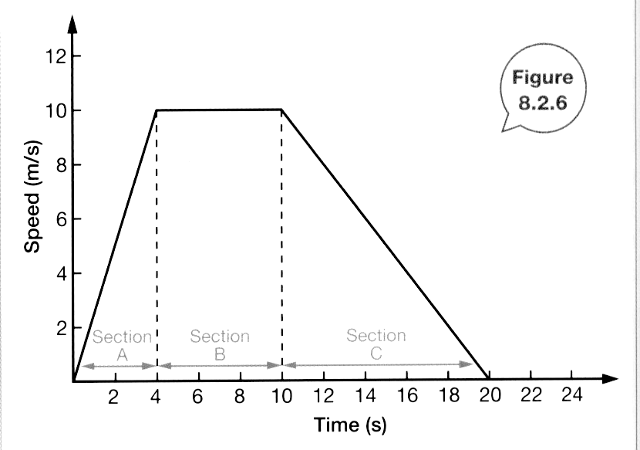

(a) During which time intervals was the bicycle travelling at a constant velocity?

(2 marks)

(b) From the area under the graph, determine the displacement of the bicycle for the 20.0 s.
(Show all of your working.)

(4 marks)
SECTION 3 COMPREHENSION (17 marks)

Read the article and then answer the questions that follow. Write your answers in the spaces provided.

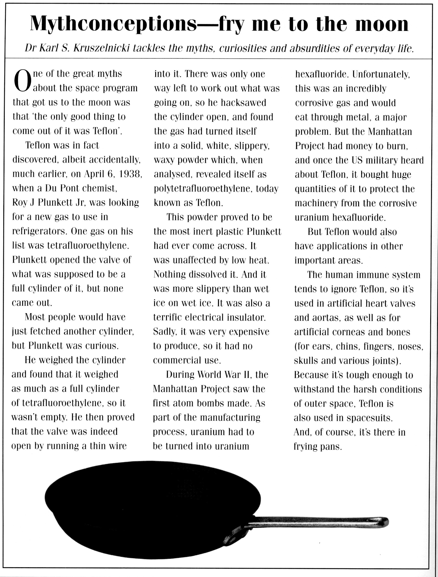
1. When was Teflon discovered and by whom?

(2 marks)

2. What is the correct chemical name of Teflon?

(1 mark)
3. Describe what Teflon looks like.

(2 marks)

4. What properties make Teflon an extremely useful material?

(2 marks)

5. Teflon is said to be inert - what does this mean?

(1 mark)

6. What research was the inventor doing when he discovered Teflon?

(1 mark)

7. What stopped Teflon from being commercially produced in the early days?

(1 mark)

8. Is Teflon a metal or a plastic? Give one piece of evidence.

(1 mark)
9. Complete the following table about the uses of Teflon.

LOCATION | USE | PROPERTY RELATED TO USES
Body
Space
Kitchen

(6 marks)

END OF EXAMINATION

THIS PAGE HAS BEEN DELIBERATELY LEFT BLANK.

THIS PAGE HAS BEEN DELIBERATELY LEFT BLANK.

